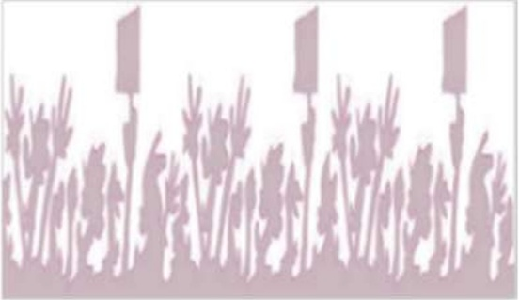

LABOUR DAY 2025

TUNE’S MAY DAY DECLARATION

FOR A EUROPE OF SOCIAL JUSTICE AND WORKERS’ RIGHTS
History has taught us that no rights have ever been granted by the ruling elite out of goodwill; every single gain has been won through struggle and collective action.
Today, May 1st, the working class of Europe and the world rises once again—not just to defend what we have won, but to demand what is rightfully ours.

For peace and against militarization
There can be no workers’ rights in societies consumed by war. We reject the war economy imposed by the elites and demand a Europe based on cooperation, not discord. No more weapons sent to war and conflict zones.
Peace is a fundamental condition for social and economic justice and development. The militarization of Europe drains resources that should be invested in revitalising the industrial backbone, creating good jobs, and strengthening quality public services. Enough of austerity measures disguised as defence policies! We refuse to foot the bill for wars that serve the interests of the powerful while the working class suffers.
In this spirit of peace, we call for the suspension of the EU Association Agreement with Israel until the end of the genocide and the systemic violations of the human rights of the Palestinian population. We stand in solidarity with all people fighting for their freedom and dignity, whose struggle reminds us that justice and human rights are indivisible.

For an industry and public services that serve the working class and the common good
Industry is the backbone of economic sovereignty, and public services are the foundation of social well-being. We demand sustainable, innovative, and fair production—where workers’ rights are respected, stable jobs are guaranteed, and progress benefits society instead of feeding corporate greed.
Europe must invest in strategic sectors, stop the destruction of industries for speculative profit, and take control of its future through technological development and ecological transition. No more factory closures dictated by corporate profits, no more essential services treated as commodities! We fight for an economy where the wealth produced by workers serves the working class, not the billionaires.

For media that serve the people, not the ruling class
We denounce the corporate-controlled media that twist narratives, silence workers, and protect the interests of the elite. Information is power, and without independent media, there can be no democracy, no justice, and no true representation of working-class struggles.
We demand a media landscape that exposes the lies of the ruling class, amplifies workers’ voices, and serves the interests of the majority - not the privileged few.

We call for mobilization across Europe and beyond
From the factories to the streets, from the neighbourhoods to the workplaces—now is the time to organize, resist, and fight back. Rights are won through struggle, justice is built through collective power, and our future depends on refusing to bow to austerity, exploitation, and oppression.
Let our voices thunder in every square, every march, and every workplace! We demand rights, justice, peace, and dignity. Workers of the world, unite!
We are resistance stitching victory through struggle!

